

|  |
| --- |
| ITECH3208 – Project 1  Sprint – 2 Outcomes Submitted to : Nityansh Rattan |
| |  |  |  | | --- | --- | --- | | Group – 1 Harmanpreet Singh Bedi 30410228 Devansh Mahajan 30423978 Sahejdeep Singh 30418751 Aakash 30397890 |  | 14/10/2024 | |

Table of Contents

Revision 3

Introduction 3

Sprint 2 3

Sprint Goals 3

Project Setup 3

Product Backlog 3

Prioritized User Stories 5

Sprint Backlog 5

Environment Setup 10

Project Management 10

Development Progress 11

Client Communication 11

Design and Data 11

Next Steps 11

Critical Revision 11

Outcomes of Sprint 2 13

# Revision

|  |  |  |  |  |
| --- | --- | --- | --- | --- |
| **Version** | **Date of revision** | **Team Members** | **Approved by** | **Brief Description** |
| 1.0 | 11/10/2024 | Harmanpreet Singh Bedi | Team Members and Client | All the mock-ups and prototypes, and sprint 2 is completed |
| Devansh Mahajan |
| Sahejdeep Singh |
| Aakash |

# Introduction

## Sprint 2

The objective of sprint 2 was to complete the designing part of the project, i.e., all the mock-ups and prototypes and gain feedback on all of the completed tasks.

## Sprint Goals

Following are the goals of sprint 2 :

* Gather feedback on the first sprint from the client.
* Document the new requirements after the feedback.
* Create remaining mock-ups and prototypes.

|  |  |
| --- | --- |
| **PBIs (Product Backlog Items)** | **Assignees** |
| Product Owner, UI/UX Designer | Harmanpreet Singh Bedi |
| Product Manager | Devansh Mahajan |
| UI/UX Designer, Tester | Sahejdeep Singh |
| Scrum Master | Aakash |

Table 1. Duties of team members in this sprint

# Project Setup

## Product Backlog

The product backlog decided (prior to the sprint) is :

1. Epic 1 : Gather Feedback and Define Requirements

This epic focuses on collecting feedback and updating the requirements based on the first sprint review.

User Stories :

* As a client, I want to provide feedback on the product's first sprint so that I can ensure the final product meets my expectations.
* As a project manager, I want to document new requirements after client feedback so that we can refine the product roadmap.

1. Epic 2 : Design Mock-ups and Prototypes

This epic involves the design process, including creating mock-ups and prototypes based on feedback and requirements.

User Stories :

* As a UX designer, I want to create mock-ups for the new requirements so that the development team can have a visual reference.
* As a product owner, I want to review the new mock-ups so that I can approve them before development starts.
* As a client, I want to see updated prototypes so that I can confirm that the product direction aligns with my expectations.
* As a UI/UX designer, I want to create interactive prototypes based on the mock-ups so that we can simulate the user experience and gather feedback.

1. Epic 3 : Develop Front-End Features

This epic focuses on the front-end development of the product, where the actual implementation of the designs takes place.

User Stories :

* As a frontend developer, I want to implement the front-end pages based on the approved mock-ups so that the product has a usable interface.
* As a user, I want the front-end pages to be responsive so that I can access the application from any device seamlessly.
* As a client, I want the front-end to reflect the updated designs so that it matches the look and feel I approved.
* As a tester, I want to review the front-end pages so that I can identify any bugs or usability issues before launch.

1. Epic 4 : Quality Assurance and Testing

This epic includes the testing activities to ensure the product meets quality standards.

User Stories :

* As a QA tester, I want to test the new features implemented in the front-end so that I can ensure they function correctly.
* As a QA engineer, I want to perform usability testing on the prototypes so that I can ensure they offer a smooth user experience.
* As a developer, I want to fix any bugs identified during testing so that the product is stable and ready for deployment.

## Prioritized User Stories

From all of the above, these are the priority user stories that are must and needed to be completed prior to moving further into the project :

* As a client, I want to provide feedback on the product's first sprint so that I can ensure the final product meets my expectations.
* As a project manager, I want to document new requirements after client feedback so that we can refine the product roadmap.
* As a UX designer, I want to create mock-ups for the new requirements so that the development team can have a visual reference.
* As a UI/UX designer, I want to create interactive prototypes based on the mock-ups so that we can simulate the user experience and gather feedback.

## Sprint Backlog

The prioritized sprints will create the Sprint Backlog for sprint 2. Here is the final sprint backlog:

* Sprint – 2
* Gather feedback from client on sprint 1 outcomes.
* Document new changes and updated requirements.
* Create remaining mock-up pages.
* Create prototypes for all the mock-up pages.

|  |  |
| --- | --- |
| **PBIs (Product Backlog Items)** | **Assignees** |
| Gather feedback on sprint 1 outcomes | Aakash |
| Document feedback | Devansh Mahajan |
| Remaining Mock-up pages | Sahejdeep Singh |
| Create prototypes | Harmanpreet Singh Bedi |

Table 2. Sprint backlog provided indicating PBIs

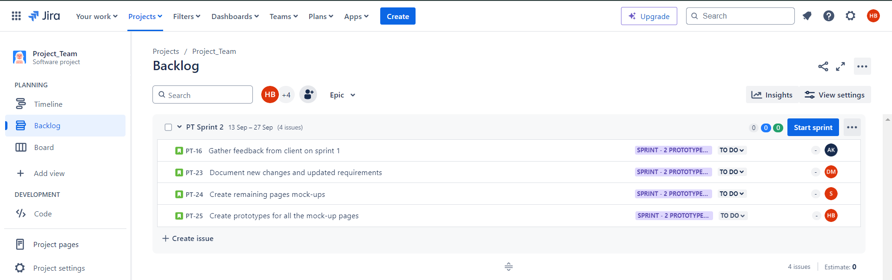Figure 1. Creating Sprint Backlog for sprint – 2

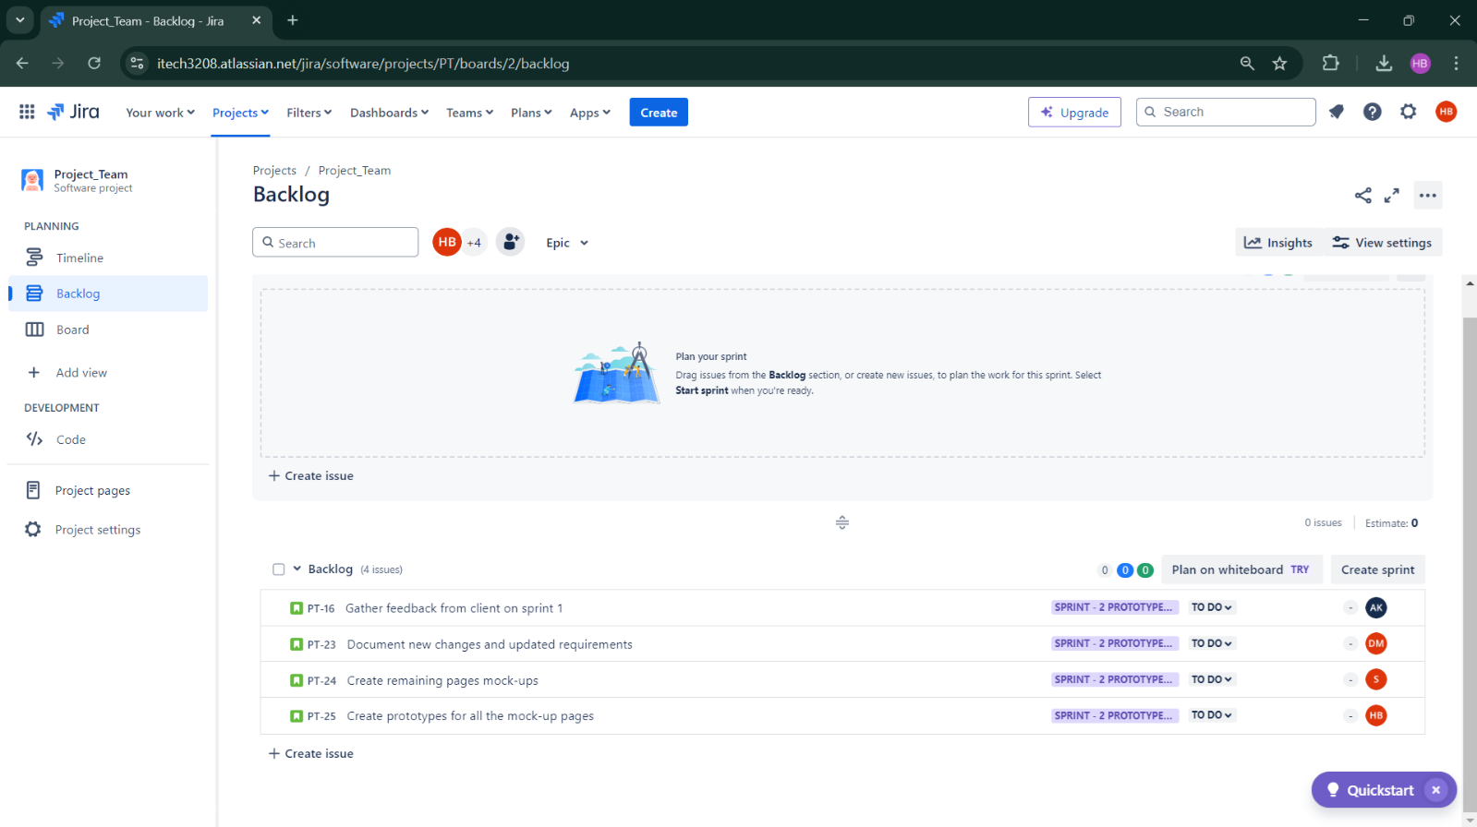

Figure 2. Sprint Backlog moved

Figure 3. Starting Sprint – 2

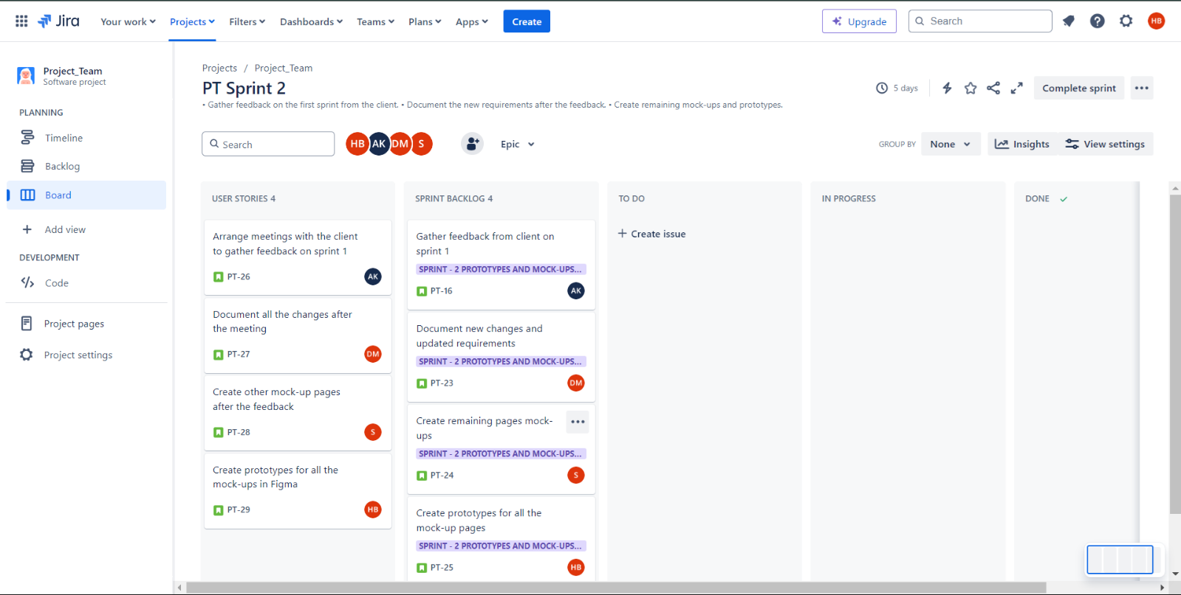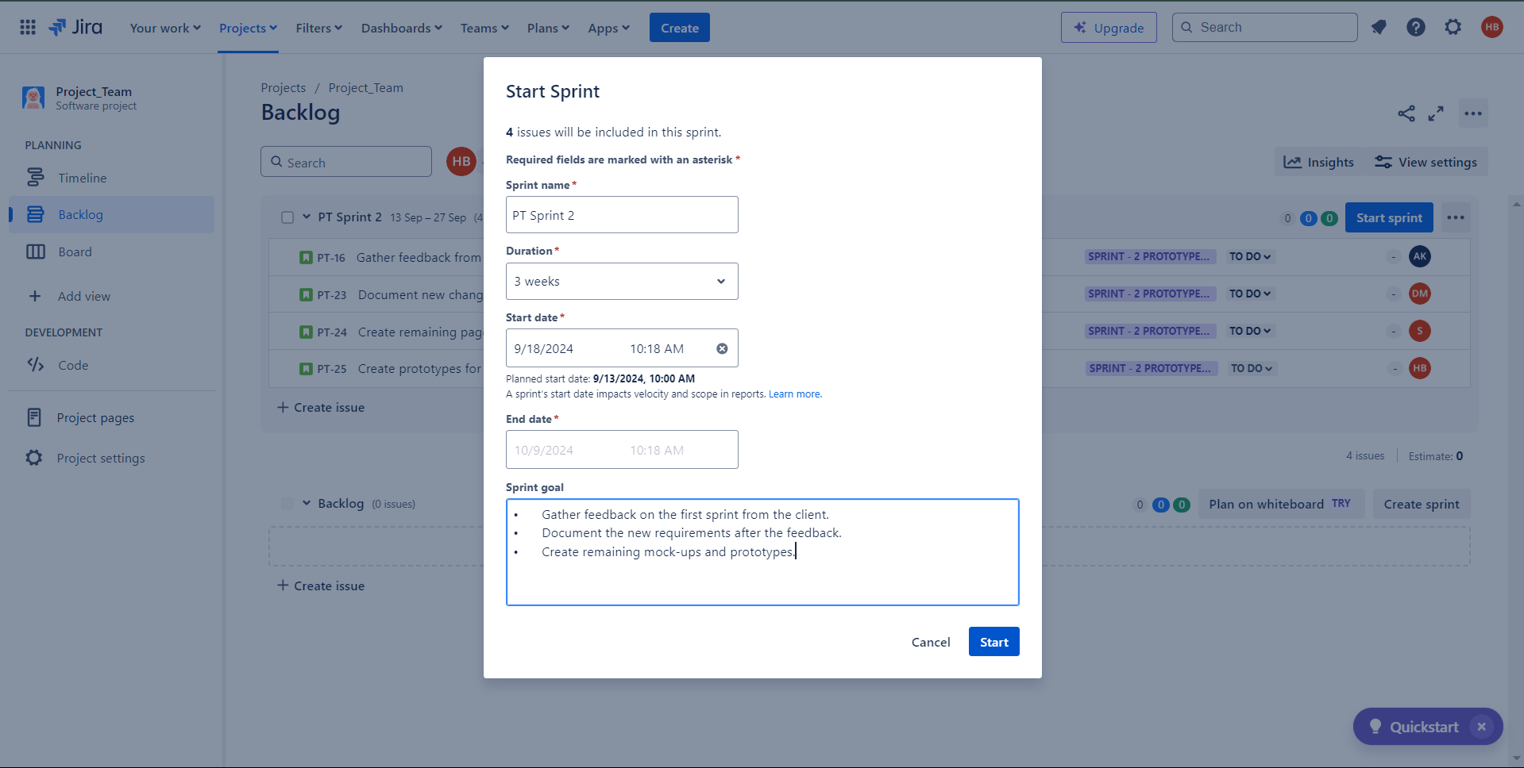

Figure 4. Jira Board for Sprint – 2 with Sprint Backlog and User Stories

Figure 5. To-Do User Stories

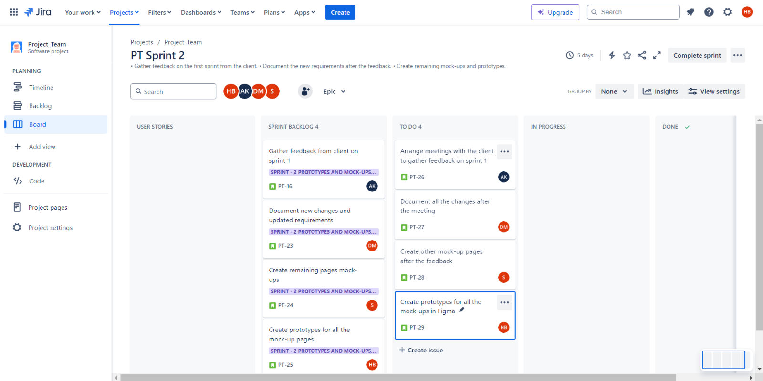

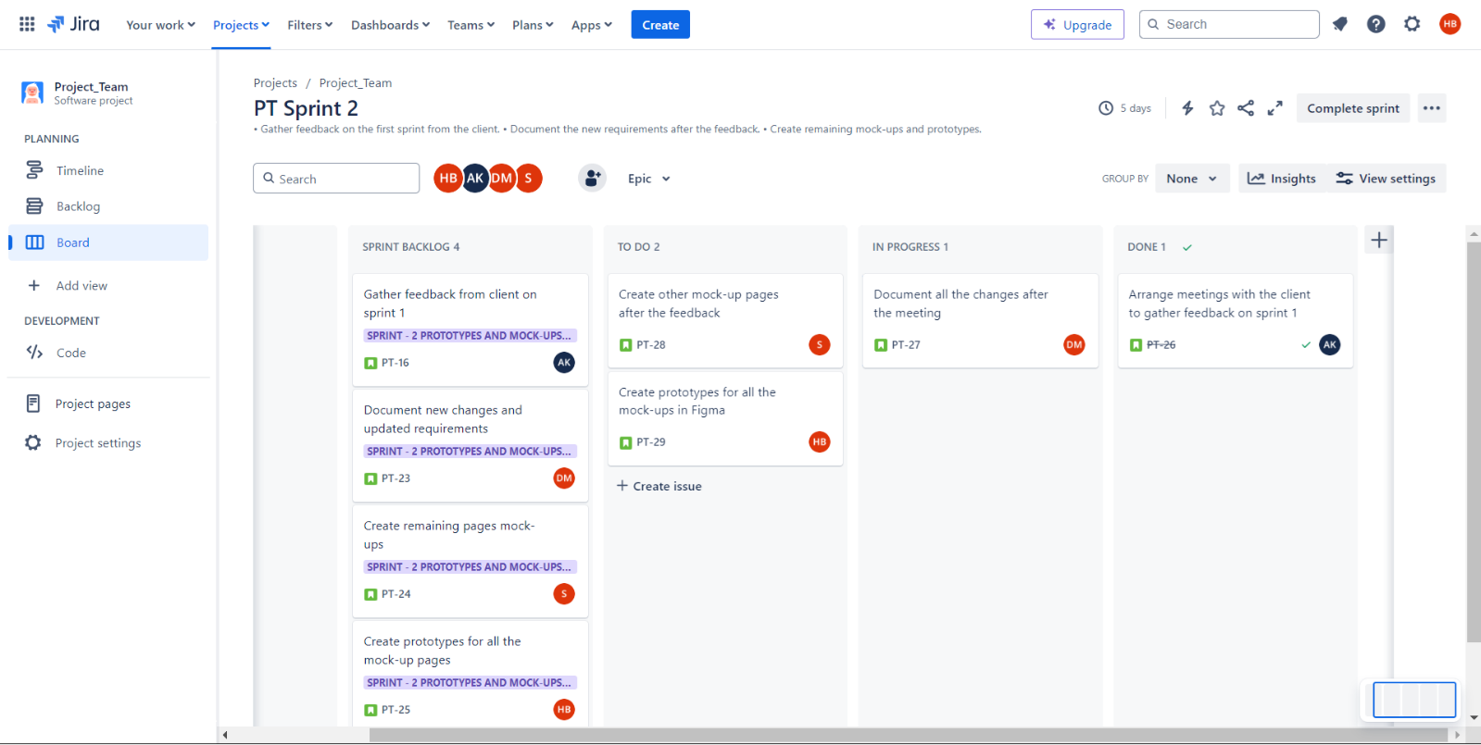

Figure 6. Progress of User Stories

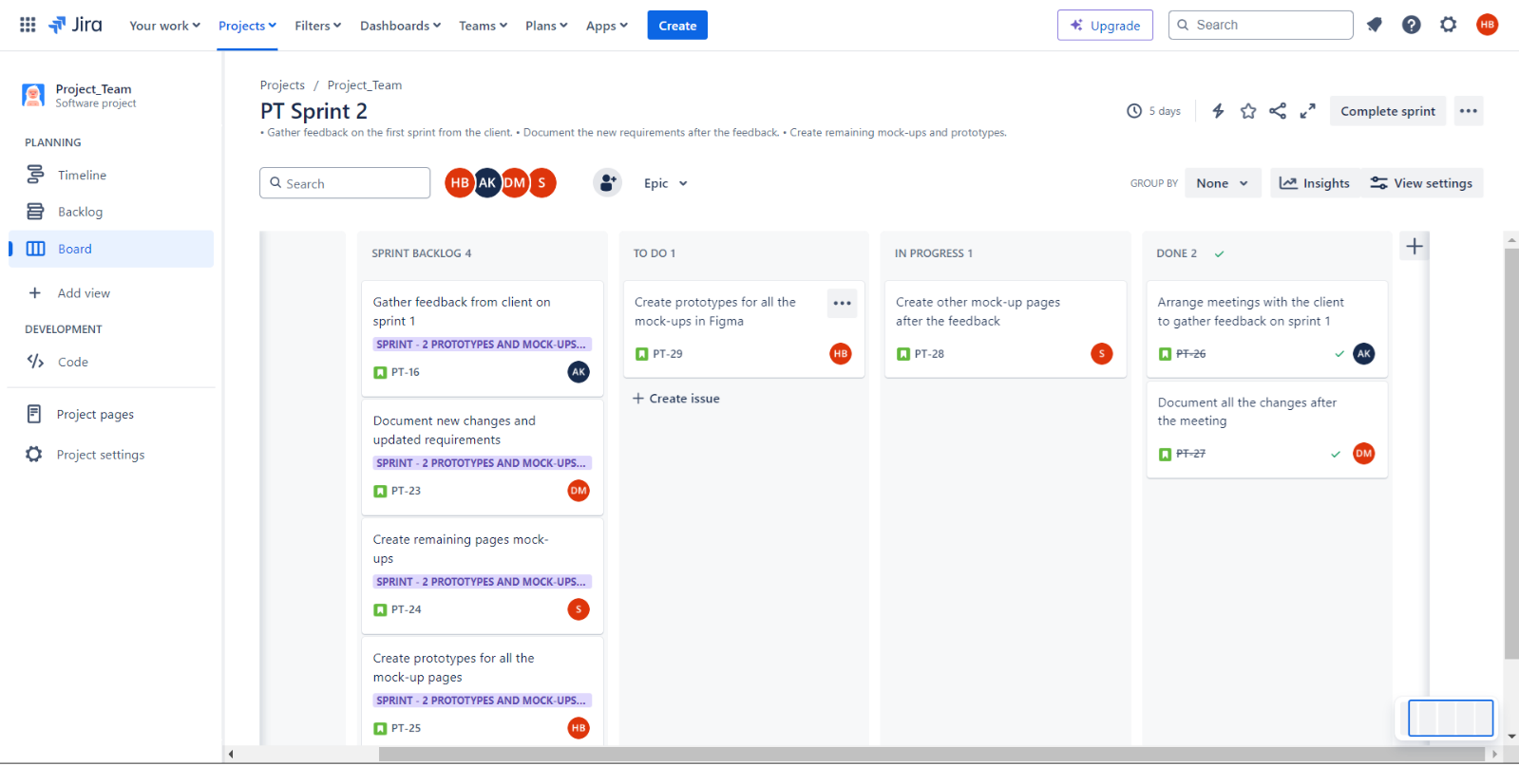

Figure 7. Progress of User Stories

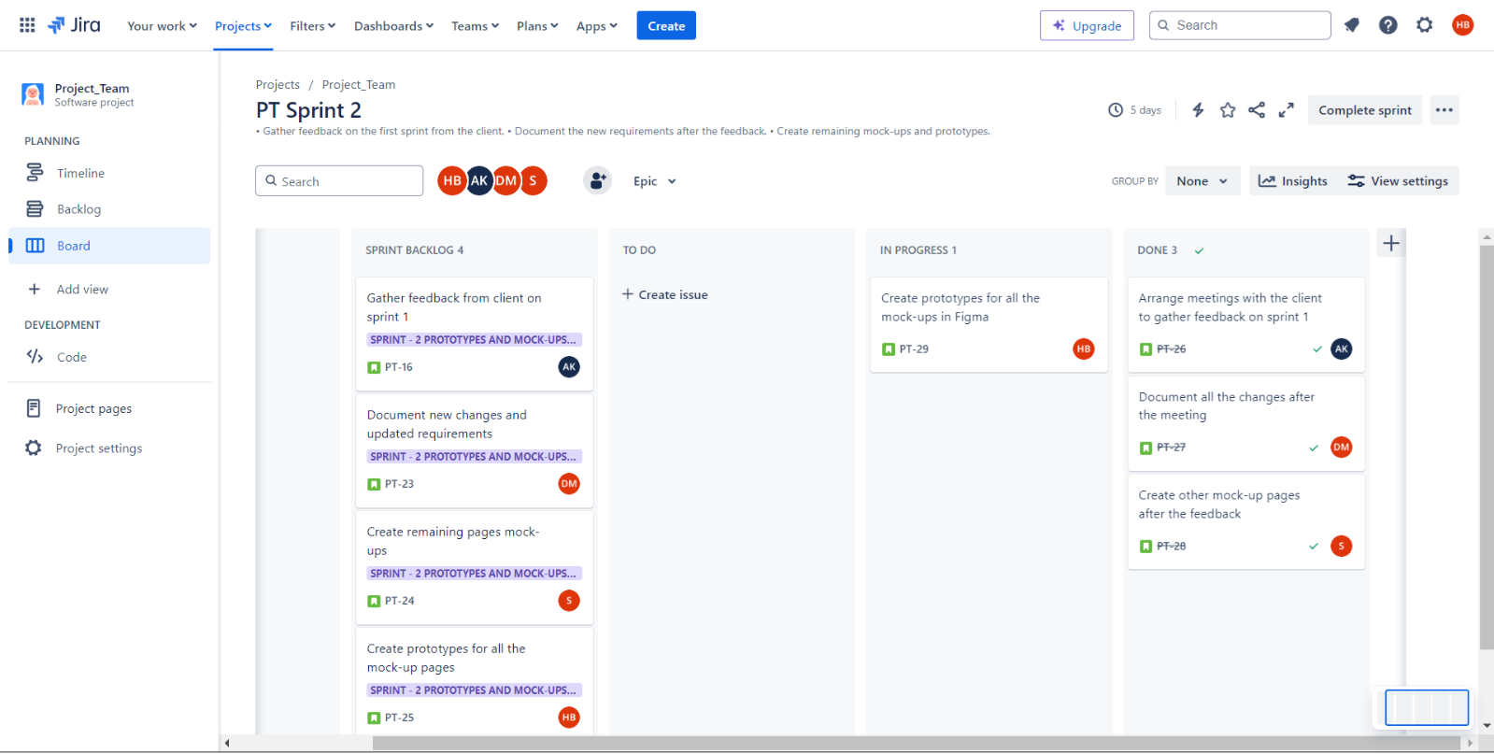

Figure 8. Progress of User Stories

Figure 9. Completed User Stories

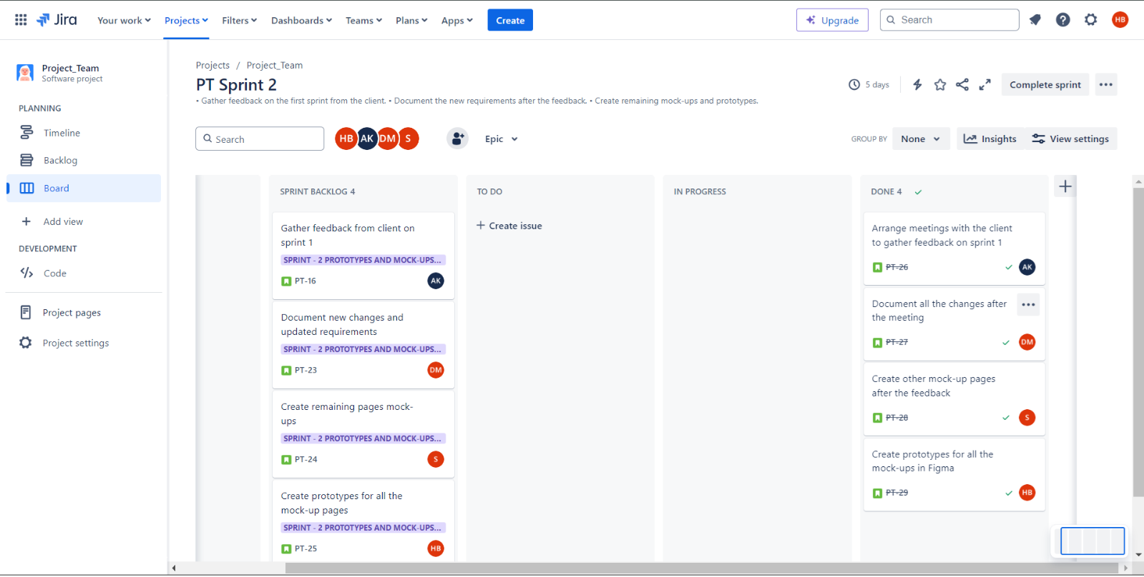

Deliverables

## Environment Setup

All the working environment that are required for the project are configured and setup. Software used :

* Documentation : Microsoft Word
* Tracking Sprint Progress : Jira Board (Timeline and Backlog)
* Mockups and Prototypes : Figma
* Coding : Visual Studio Code
* Local backend server : XAMPP
* Testing : Web Browsers like Google Chrome, Edge and Firefox
* Meetings : Microsoft Teams

## Project Management

Jira is used efficiently for project management. It defines product backlog, user stories, tasks and sprint backlog along with To-Do, In Progress, and Done lists to define tasks and track progress.

## Development Progress

In this sprint, the project team successfully gathered feedback from the client on the outcomes of sprint – 1. Also, the team successfully completed the designing part of the project, i.e., all the mock-ups and prototypes.

## Client Communication

Client feedback meeting was held before starting the sprint, to get the feedback on the sprint 1 outcomes. This helped us to gain an early insight about the team’s progress track and gather feedback on that.

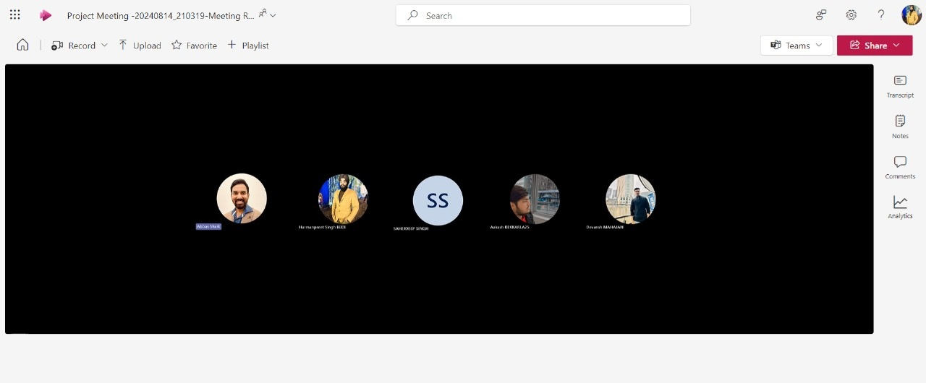

Figure 10. Client feedback meeting in early stages of development

## Design and Data

When the mock-ups were created and ready, that provided a visual roadmap about the project. Although only three pages were ready, we were able to visualize client’s requirements and project development.

## Next Steps

The next steps will contribute towards completion of sprint – 2. It will include building prototypes and mock-ups for all the portals and complete website.

# Critical Revision

A backlog refining meeting was conducted and following is the refined product backlog with set priorities :

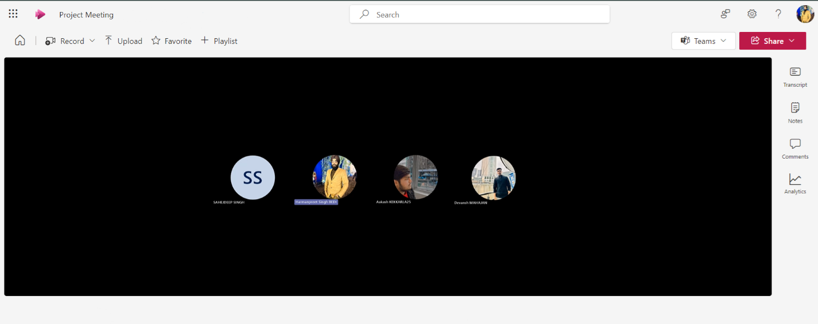

Figure 11. Backlog refining meeting

|  |  |
| --- | --- |
| **Refined PBIs** | **Priority** |
| 1. Epic 1 : Gather Feedback and Define Requirements   This epic focuses on collecting feedback and updating the requirements based on the first sprint review.  User Stories :   * As a client, I want to provide feedback on the product's first sprint so that I can ensure the final product meets my expectations. * As a project manager, I want to document new requirements after client feedback so that we can refine the product roadmap. | High |
| Epic 2 : Design Mock-ups and Prototypes  This epic involves the design process, including creating mock-ups and prototypes based on feedback and requirements.  User Stories :   * As a UX designer, I want to create mock-ups for the new requirements so that the development team can have a visual reference. * As a product owner, I want to review the new mock-ups so that I can approve them before development starts. * As a client, I want to see updated prototypes so that I can confirm that the product direction aligns with my expectations. * As a UI/UX designer, I want to create interactive prototypes based on the mock-ups so that we can simulate the user experience and gather feedback. | High |

Table 3. Revised Product Backlog

# Outcomes of Sprint 2

Goals were identified and deliverables are of high quality, and are according to the client’s requirements.

1. Feedback :

The feedback for sprint – 1 outcome was gathered from the client. All the things and documentation went well and all the specifications and designs were according to the requirements of the client.

We recorded no significant change from the client.

Figure 12. Client feedback meeting

1. Remaining mock-up pages :

In sprint 1, we completed mock-ups for three pages, that are : the Login page, Home page and the Products page.

That designs were according to the client requirements and specifications.

So, we moved further in creating the remaining mock-ups for all the other pages.

Figure 13. Categories page mock-up

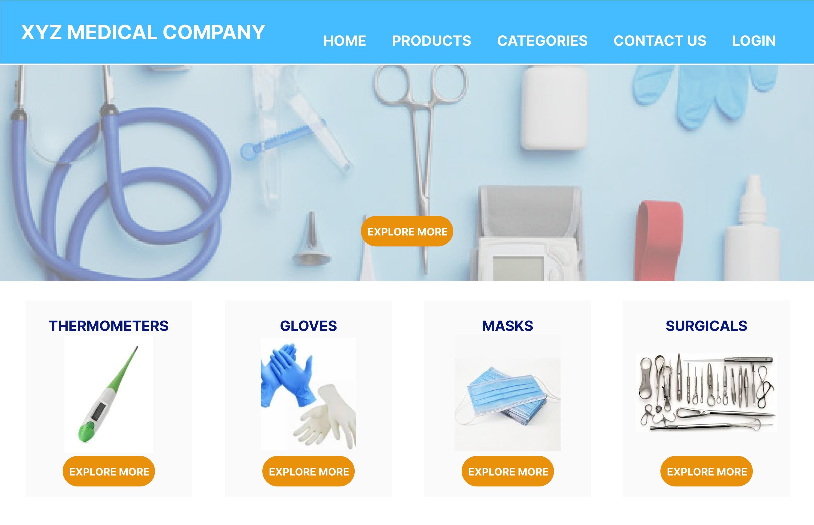

Figure 14. Contact page mock-up

1. Prototype :

Prototype consists of clickable flow made from mock-up pages.

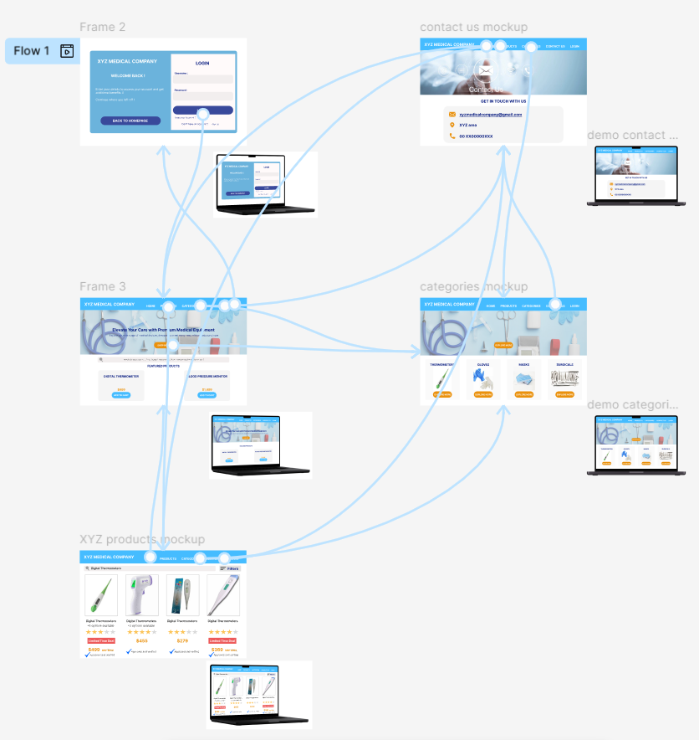This prototype was made after the completion of all the mock-up pages.

Figure 15. Prototype

Link to the prototype : <https://www.figma.com/proto/fsX4U5KlEV9VHV7vsx6yMu/Project_1-Mock-ups?node-id=0-1&t=48IZGnvU5NQPmWtU-1>

1. JIRA Board :

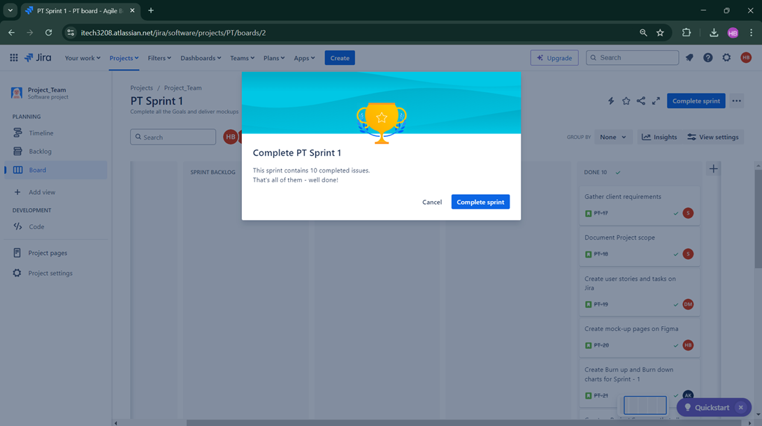

Figure 16. Previously completed sprint – 1



Figure 17. Creating Sprint Backlog for sprint – 2



Figure 18. Sprint Backlog moved



Figure 19. Starting Sprint – 2



Figure 20. Jira Board for Sprint – 2 with Sprint Backlog and User Stories



Figure 21. To-Do User Stories



Figure 22. Progress of User Stories



Figure 23. Progress of User Stories



Figure 24. Progress of User Stories



Figure 25. Progress of User Stories

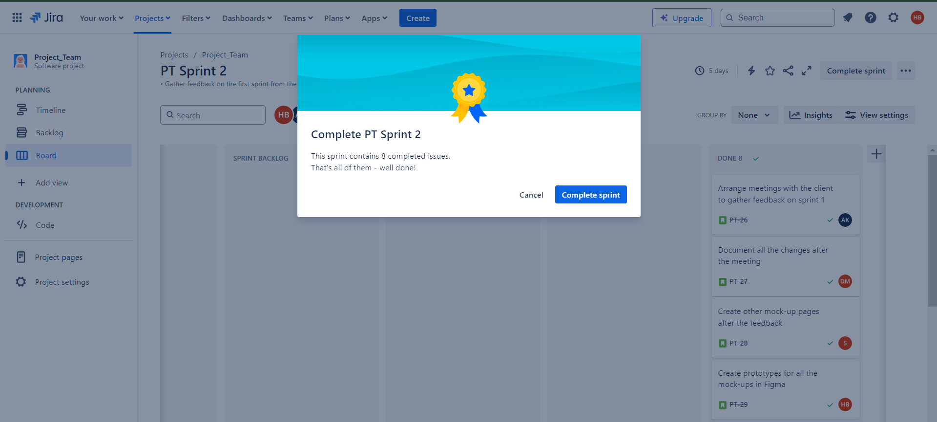

Figure 26. Completion of Sprint – 2

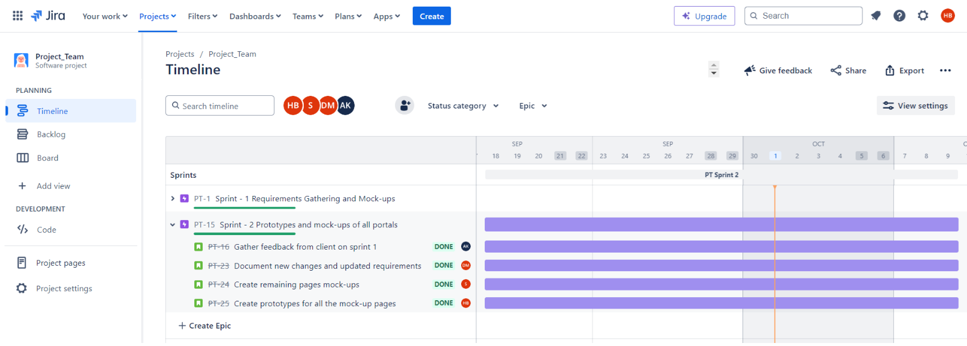

Figure 27. Sprint – 2 Timeline

1. Meetings

Client Feedback meeting



Figure 28. Client Feedback Meeting

Sprint end retrospective meeting



Figure 29. Sprint – 2 Retrospective Meeting

In the retrospective meeting, we did some question analysis :

* What I did ?
* What are the remaining tasks ?, and
* What challenges I faced in my tasks ?

Every member was encouraged to give answers to these questions :

|  |  |
| --- | --- |
| **Questions** | **Answers of members** |
| What I did ? | Harmanpreet Singh Bedi : My task in this sprint to evaluate every task’s progress, make remaining mock-up pages and prototypes for all the mock-ups. |
| Devansh Mahajan : I was responsible for documenting any further suggested changes by the client after the completion of the Sprint – 1. |
| Sahejdeep Singh : I made the remaining mock-ups for the other pages. |
| Aakash : I gathered feedback from the client for the Sprint – 1. |
| What are the remaining tasks ? | Harmanpreet Singh Bedi : As of now, no remaining tasks are left. |
| Devansh Mahajan : No remaining tasks. |
| Sahejdeep Singh : No remaining tasks left. All the mock-ups are completed. |
| Aakash : All tasks are done. |
| What challenges I faced in my tasks ? | Harmanpreet Singh Bedi : The major challenge in this sprint was to schedule and match timings. |
| Devansh Mahajan : No such challenge faced. |
| Sahejdeep Singh : No challenge. |
| Aakash : No challenge. |

Table 4. Retrospective meeting Outcomes

Link to our Jira board : <https://itech3208.atlassian.net/jira/software/projects/PT/boards/2>